Press Release

War in Ukraine: Response of the Moscow Patriarchate to the COMECE letter
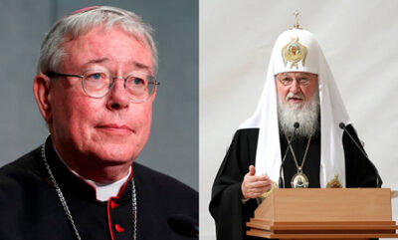
Cardinal Hollerich (left) and Patriarch Kirill (right)

Following the letter addressed to Moscow Patriarch Kirill from H. Em. Cardinal Jean-Claude Hollerich SJ, President of COMECE, earlier in March 2022, we share the response provided by H. Em. Metropolitan Hilarion of Volokolamsk, Chairman of the Moscow Patriarchate department for external church relations.

Click here to read or download the letter (RU – EN)

